**Tips and tricks for formatting in reports**

**Introduction**

Formatting plays a pivotal role in enhancing the visual appeal and readability of reports in Microsoft Power BI. A well-formatted report not only engages users but also effectively communicates insights. Power BI provides many ways to format and customize your reports. Below are some tips to elevate your Power BI visualizations to make them more compelling and engaging.

**Use Power BI themes.**

Power BI themes provide a quick way to change the look of the entire report. When you apply a theme, all visuals in your report use the colors and formatting from the selected theme. Use a theme in your report to provide consistency, maintain the brand identity, and get a better user experience and professionalism in your report design. Theme selection also enables you to address accessibility in your reports and dashboards.

The default colors in your report will adjust when you apply a template.

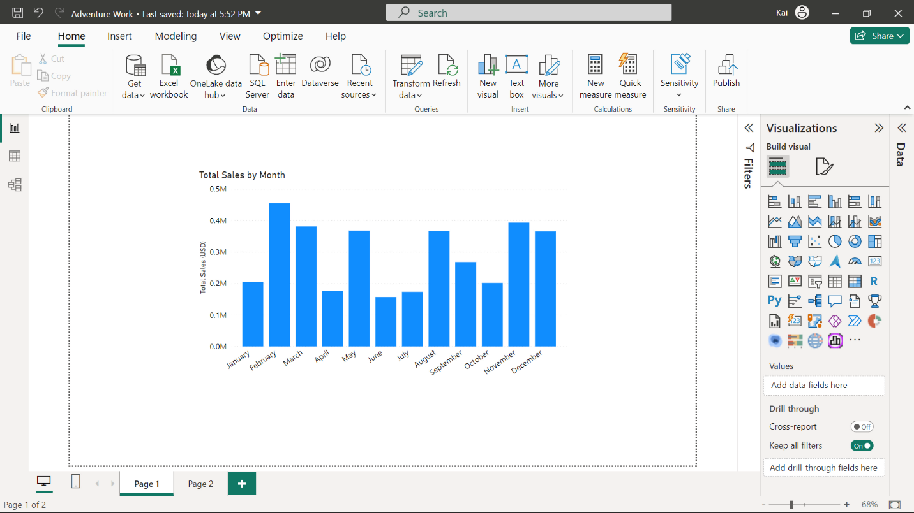

Apply a template from the View tab of Power BI.

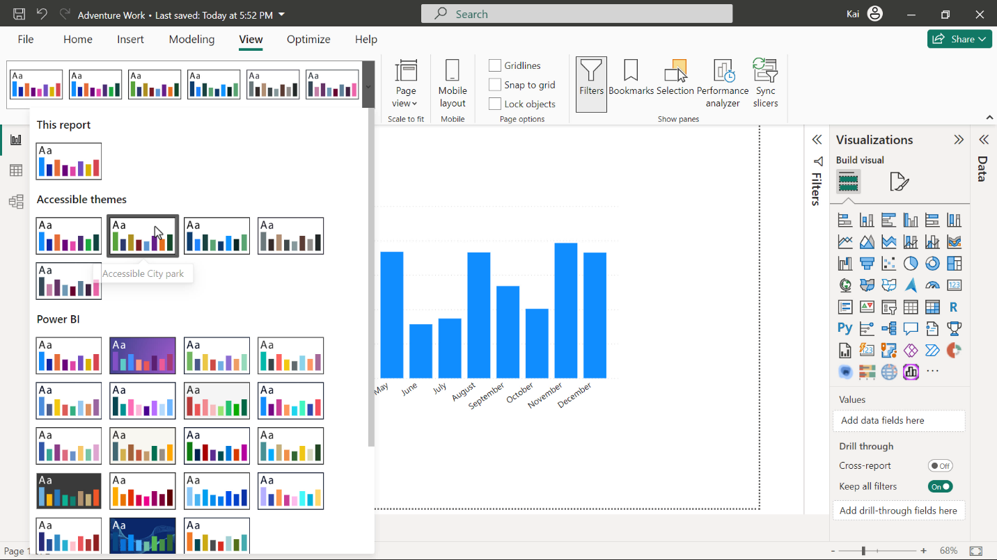

When the template is applied, check the color changes to ensure they match your requirements.

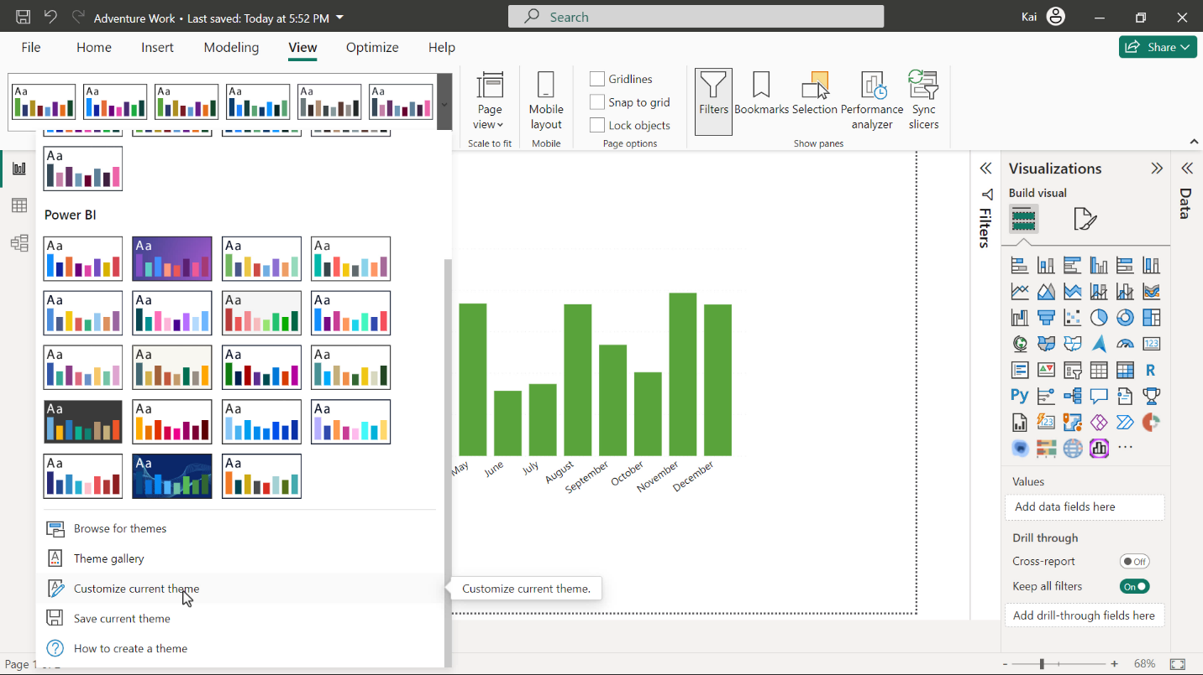

**Built-in themes**

Power BI desktop has built-in report themes that have pre-defined color schemes. You can customize the theme that you are currently using by changing the hues, saturation, and lightness according to your personal or corporate needs and save the theme in Power BI for later use in other reports.

**Custom themes**

If your organization has designed its own color palette and wants to create a fully customized theme for all its reports, you can create this using a JSON file and upload it to Power BI.

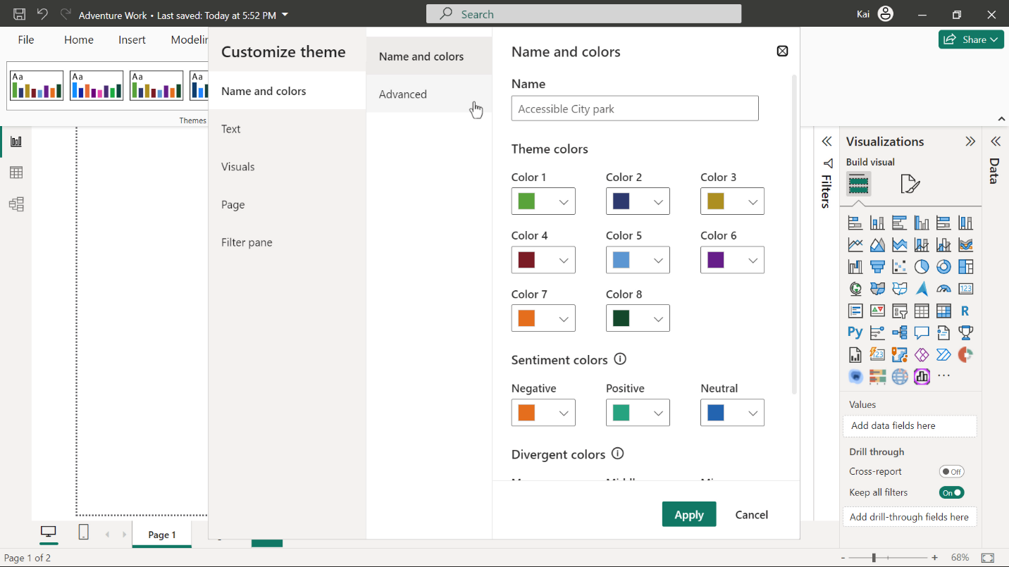

**Conditional formatting**

Conditional formatting allows you to dynamically change the color of your visual based on specific conditions or rules. This allows you to draw attention to and highlight specific information in numeric or text fields using colors, icons, or bars. You can apply the following formats in conditional formatting:

* Background color
* Font color
* Data bars
* Icons
* Web URL

For example, if Adventure Works wants to analyze the sales of its categories or subcategories, you can apply conditional formatting with a color gradient, the darkest color showing the highest sales and the lightest being the lowest sales values.

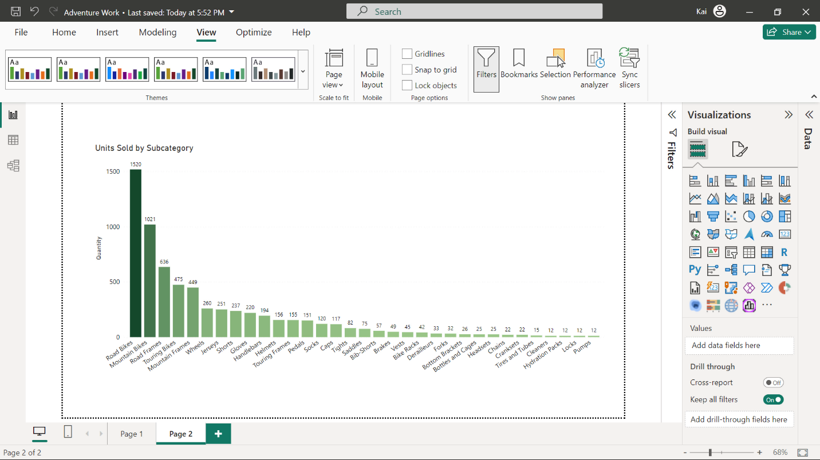

**Use of diverging colors**

Imagine you are a data analyst in an environmental agency and must analyze temperature data for a specific region. As a temperature range has a neutral midway point, you can use green and red as two extremes of a color gradient in conditional formatting to highlight the positive and negative values within the scale.

In a similar approach to conditional formatting at Adventure Works, you are asked to evaluate the profit margin for each category in each region. Using conditional formatting, you can represent the range of profit margins for each category and region.

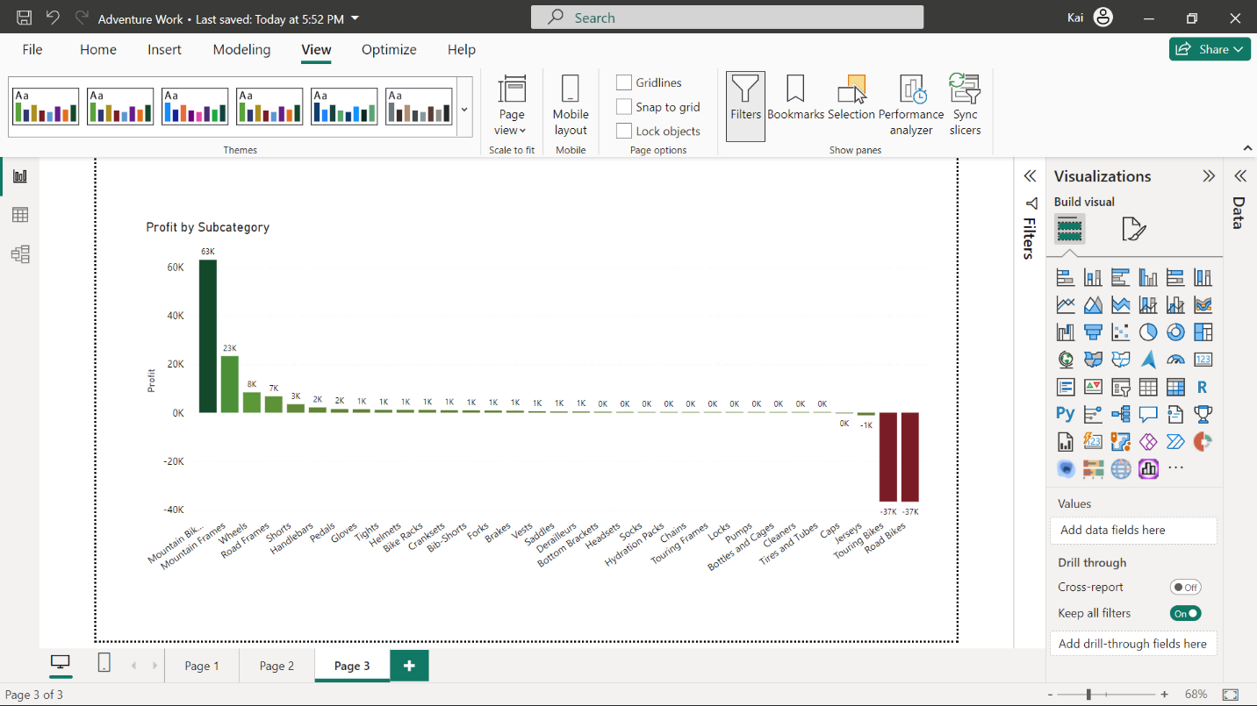

**Use of data bars**

Data bars give you colored bars like a bar chart. You can set colors for positive and negative values based on maximum and minimum values in your data.

For example, if you want to present the profit margin either as positive or negative without the range, you can apply data bars with red color as negative and green as positive.

**Formatting color of individual data points**

Conditional formatting changes the color of entire datasets, but what if you want to change the color of only one column or bar in your visual? Power BI provides you with the freedom to accomplish that. For example, at Adventure Works, if you want to highlight one data point to grab the attention of viewers, you can employ selective coloring to all your data points in Power BI.

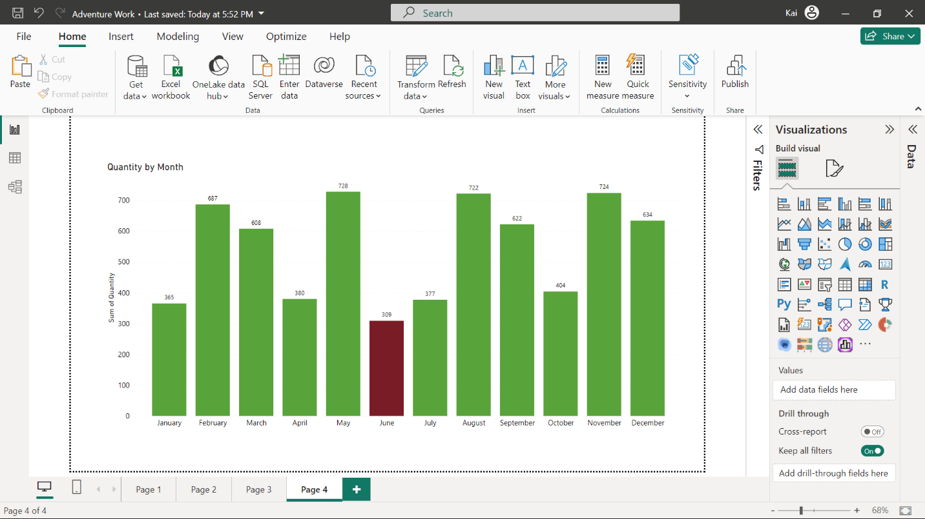

**Changing the color of all data points**

If your organization has brand colors and wants to use them in all the charts in Power BI, you can color each data point of your visual individually. For example, you want to present the regional sales data for Adventure Works by representing each country with a distinct color.

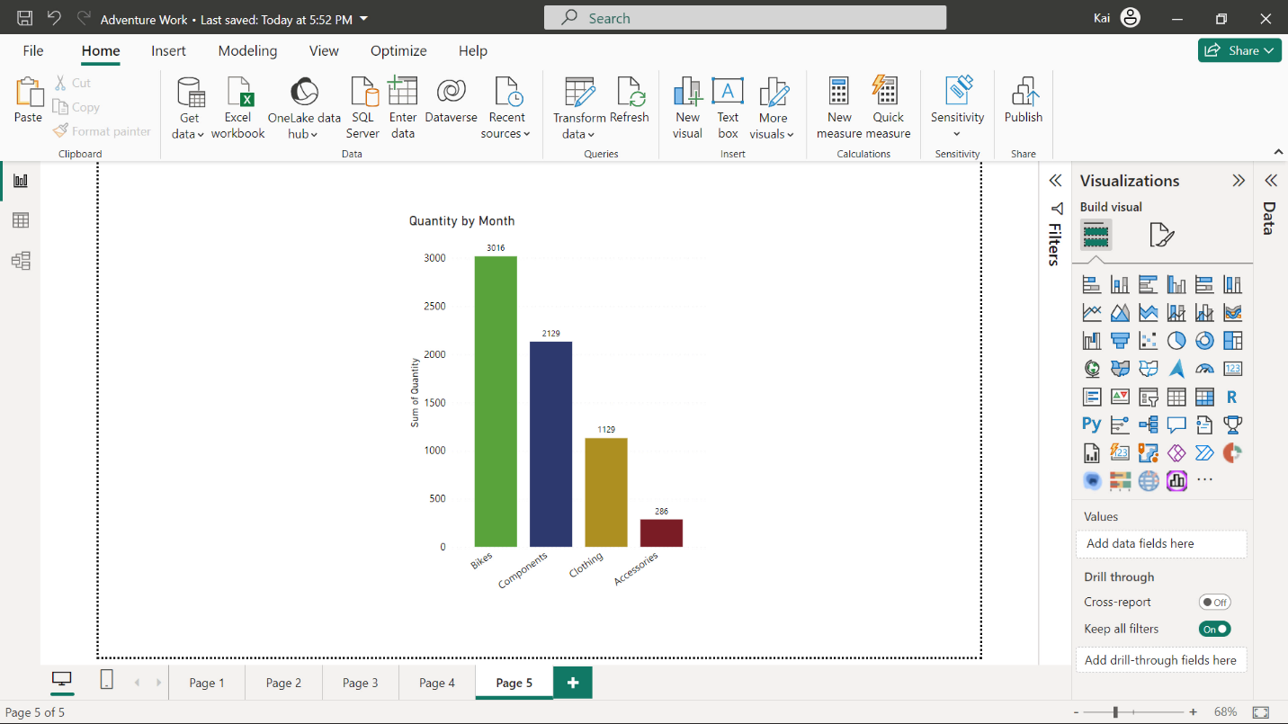

**Formatting a table visual**

Power BI provides some table-style preset options that you can use as a formatting starting point. Furthermore, you can format column headers and values. In both these categories, you can format background colors and text colors to meet your specific analytical or business needs.

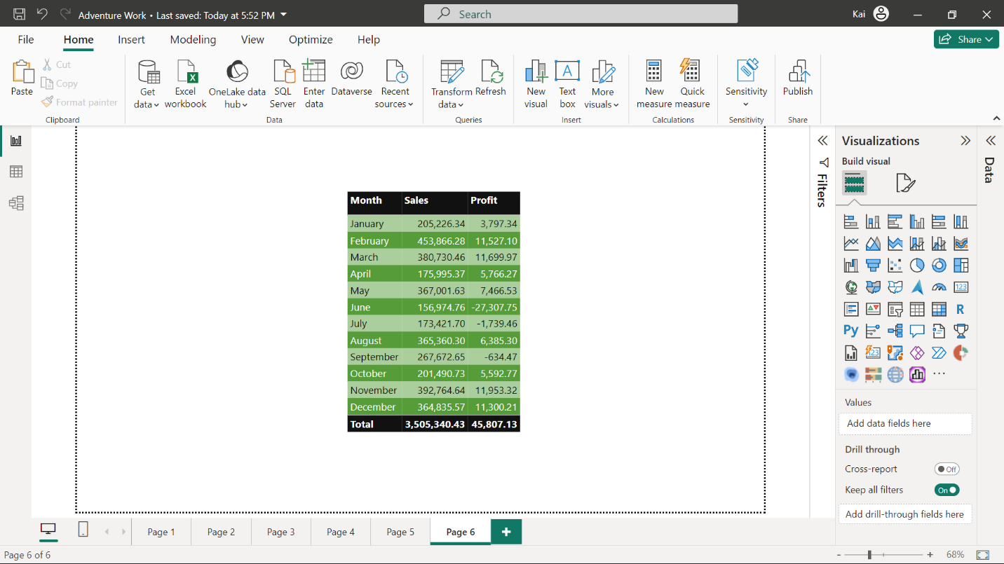

**Additional best practices for report formatting**

* **Consistent color palette:** Select a harmonious color palette that aligns with your brand or theme. Consistency in color not only aids the look of the report or dashboard but also helps in associating different visualizations with specific data categories.
* **Font choices:** Select legible fonts that ensure easy readability across devices. Balance a body font with a header font to maintain the professional appearance of your reports.
* **Whitespace utilization:** Embrace whitespace to declutter the appearance of reports. Proper spacing between the visuals and text elements prevents visual overload.
* **Borders and lines:** In reports, the strategic use of borders and lines helps separate various sections, highlight key messages, and guide the viewer’s eye through the report.
* **Alignment and grids:** Align elements and visuals consistently to create a neat and structured layout. Grids can be helpful in maintaining the uniformity of a Power BI report.
* **Background and images:** You can incorporate subtle background colors and images that complement your report’s theme. If you are using background colors or images, you need to make sure they are not distracting the viewer from the main message of the report.
* **Responsive design:** Choose a responsive design that easily adapts to various screen sizes, thereby enabling users to access your work on different devices.

**Conclusion**

Proper formatting in Power BI reports is key to effective communication and data interpretation. Implementing these tips and tricks can transform a mundane report into an engaging, insightful, and user-friendly experience. With practice, you can empower your reports to effectively convey data-driven stories that connect with your audience.